**Exp No: 6**

Applying DML commands on Road Way Travels Tables. Data Manipulation Command

Data Manipulation commands are most widely used SQL commands and they are

• Insert

• Update

• Delete

• Select

1.Insert

*insert into student(ID,Name,branch,email) values (1,"sarayu","cse","sarayu@gmail.com");*

*insert into student(ID,Name,branch,email) values (2,"lee ","eee","lee@gmail.com");*

*insert into student(ID,Name,branch,email) values (3,"pan","ece","pan@gmail.com");*

*select * from student;*

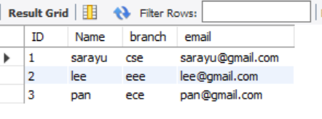





2. Update

*alter table student add course char(6);*

*update student set course = 'M' where ID = 1;*

*select * from student;*



3.Delete

*DELETE FROM student WHERE Name = 'pan';*

*select * from student;*

4.Select

*select * from student;*

*select *from student where branch = "ece";*

*select *from student where branch in ("cse","ece");*

*insert into student(ID,Name,branch,email) values (4,"min","it","min@gmail.com");*

*insert into student(ID,Name,branch,email) values (5,"kim","eee","kim@gmail.com");*

*insert into student(ID,Name,branch,email) values (6,"jhope","ece","jhope@gmail.com");*

*select * from student where ID = 4 and Name = "min";*

*select * from student where ID = 4 or Name = "kim";*

